**Functional requirements** = add item, remove item, view item

**Non-functional requirements** = reliability, usability, availability.

**System architecture diagram**

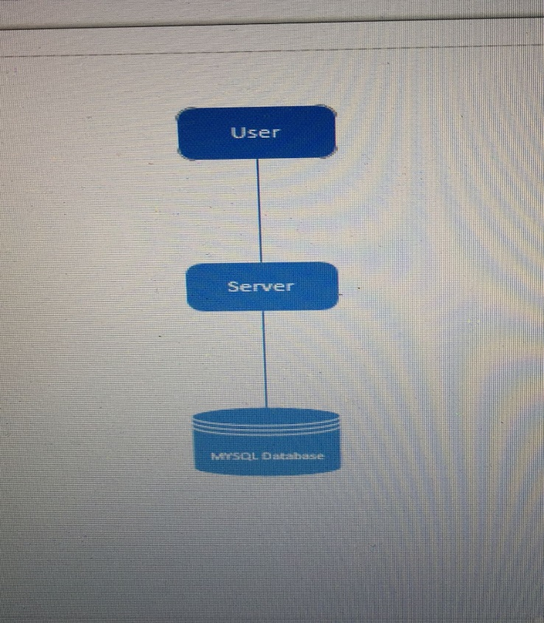

**Use case**

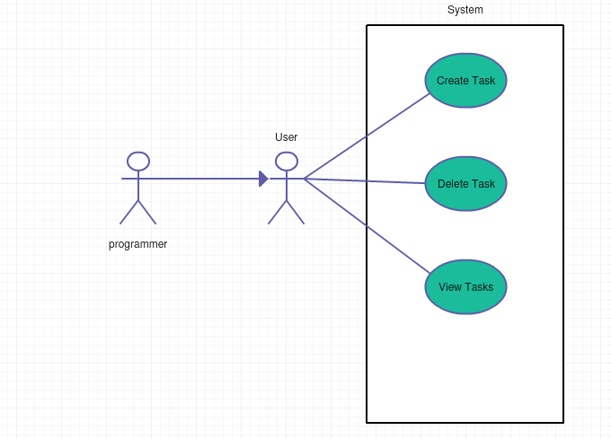

**Database design**

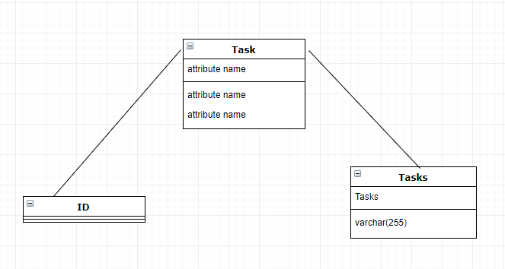

**Class diagram** 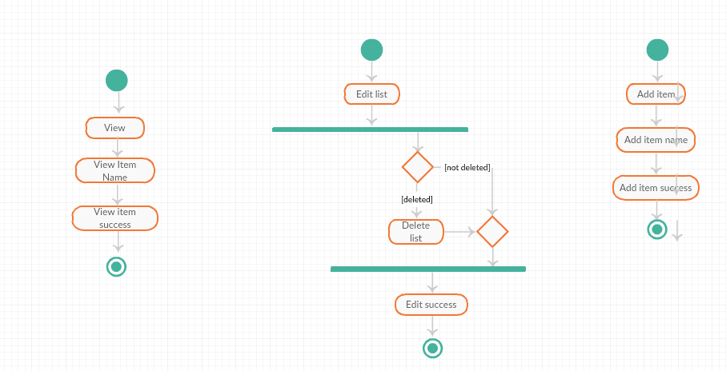

**Test case**

TC01- Add tasks

Precondition: know the task ahead of time

Assumption:

Test steps:

1. Type in task
2. Click add item

Expected results: after pressing add task, the task should be added to the list

TC02- View tasks

Precondition: know the task ahead of time

Assumption: application remembers the input from the user

Test steps:

1. After typing add task, all of them should come up with their number of addition, the task, and remove button

Expected results: all of the tasks should come up for the user to see.

TC03- remove tasks

Precondition: every task should have a remove button next to it

Assumption: only remove the task that the user selected to remove

Test steps:

1. Next to all of the tasks, is a red x button
2. Press x button
3. The task will be removed

Expected results: remove the task when button is clicked

Task:Add

Took about 2 hours

Task:Delete

Took about 4 hours